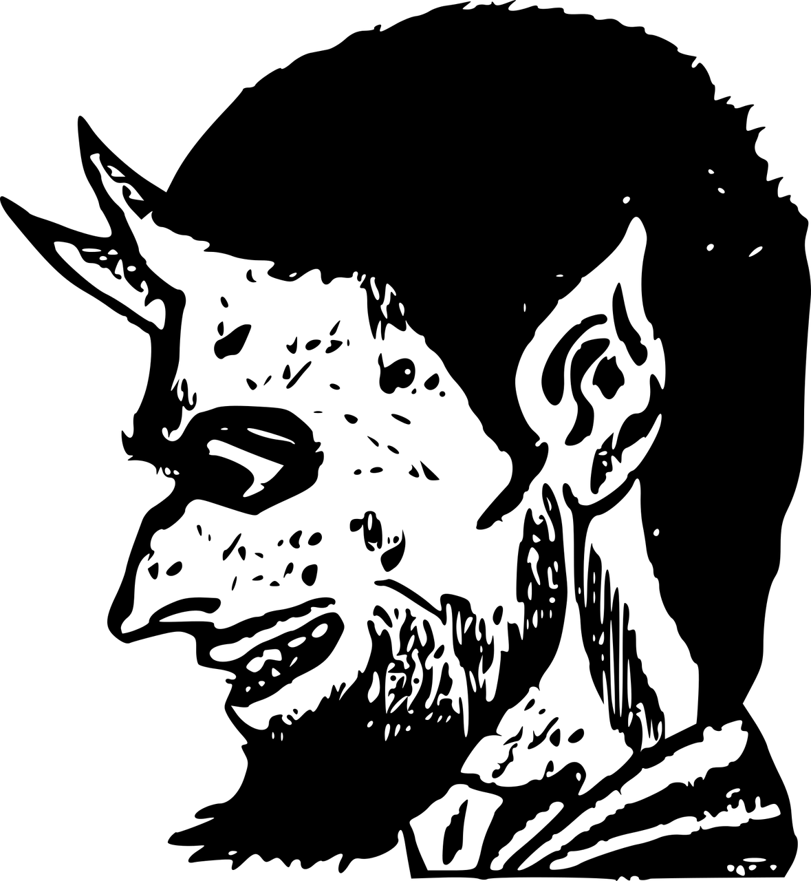

The origin of Satan

Letter to the attention of His Excellency Prime Minister Benjamin Netanyahu
Shalom

Satan was called “the Enemy” during WWII, in which they confused the Jews with the Israeli, through which the Jews got massacred and the Enemy survived. It is therefore not in the interest of the Jews to conspire with the Israeli, because the same Enemy will do this again to them.

The people of Israel don't come from the country of Israel, because that country was created in 1948. They originally come from Engis in Wallonia, where the oldest bones of this prehistoric human species were found (). I will explain in a minute what the prehistoric human being has to do with Israel.

The prehistoric human being in West Europe is the Neanderthal. The chances are that the population which settled throughout that region where the oldest bones were found, are direct descendants of the Neanderthal. There is conclusive scientific evidence that the DNA of the Neanderthal was found in certain populations in Europe and North Africa ,,. The settlements around the fossil sites of the Neanderthal count populations who are carriers of Neanderthal DNA.

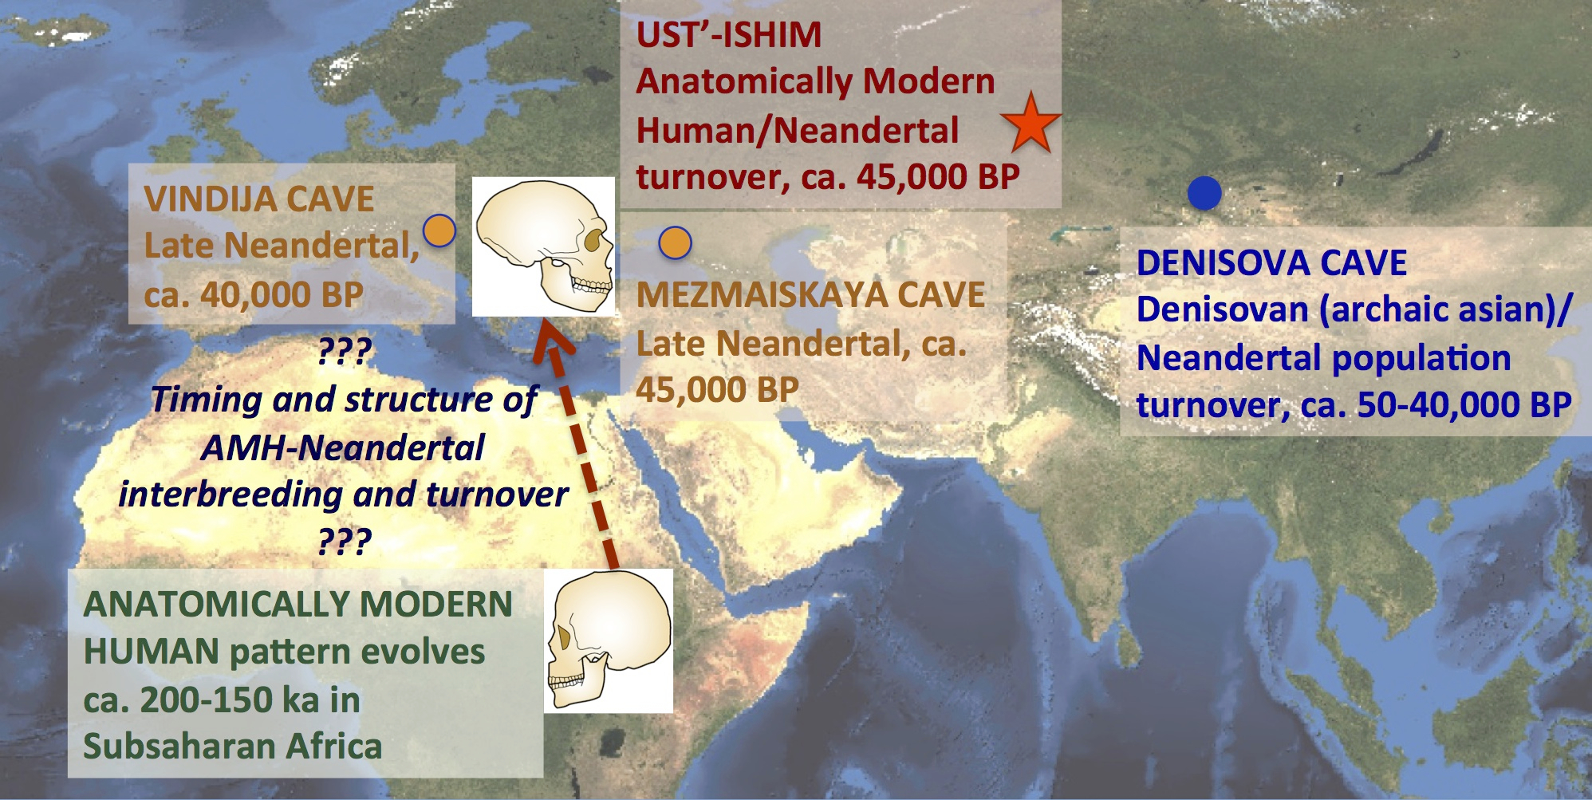

Neanderthal DNA is not human DNA, but animal DNA, as was confirmed by zoological research. A Neanderthal is according to Oxford Dictionary “regarded as a separate species from H. sapiens and probably at the end of a different evolutionary line”, and “an uncivilized, unintelligent, or uncouth man”.

A Neanderthal is according to Merriam Webster dictionary “a Homo neanderthalensis syn H. sapiens neanderthalensis, […] called also Neanderthal man.”

Any dictionary will indicate that the Neanderthal is not the Homo Sapiens, that the species is a different category. There are more and more scientists who come to the conclusion that the Neanderthal is a distinct species from the modern humans, like the Oxford Dictionary says, and that he is rather related to the chimpanzee

It is not a human like the modern man. It is not an animal like the pig. It is a third kind of being that is neither a man, nor an animal. It is a being that has both human blood and animal blood running in its veins. This kind of being is a hominid.

A hominid is according to Merriam Webster dictionary « Any of a family (Hominidae) of erect bipedal primate mammals that includes recent humans together with extinct ancestral and related forms and in some recent classifications the gorilla, chimpanzee, and orangutan.

It seems that both hominid and Neanderthal are the same, given the reference to an “extinct ancestral” and to the chimpanzee. I also find that they know too much about the Neanderthal to pretend that he got extinct thousands of years ago or that he got promoted to Homo Sapiens. If he got extinct, how come they found Neanderthal DNA in certain European and North African population and not in others ? If he was promoted to Homo Sapiens, were all the Neanderthals promoted on the same ? That is impossible. Say what you like, whether was promoted or extinct, he was a pre-historic being. He was not the Modern man. He was a hominid.

A hominid is a human lookalike, just like a wolf is a lookalike of a dog, and a cat is a lookalike of a puma. A bee is a lookalike of the wasp, but the behavior is different. In the realm of plants you have the same: a daisy is a lookalike of the sunflower, a tangerine is the lookalike of an orange and a lemon, but the taste is different. When you have this with everything, it is normal to have this also in the human category. A hominid is that savage and devious version of the human being. In other words he is a primate, like an ape, but, he is evolved. it is a primate who can talk and do nearly everything like the human being. If parrots and dolphins were given speech, why not an ape or a monkey ? The only big challenge about the Neanderthal is that he looks almost identical to the West European modern man (Cro-Magnon), but he is an ignorant and he engages in battle and strife to ensure his own survival, whereas the Cro-Magnon survives with intelligence and belief.

They can lie as much as they want about the Neanderthal being extinct, but the truth will prevail when a direct link is established between genetics, behavior and diseases, like HIV, cancer,,,,,,, certain forms of dementia, longevity, low birthrates and the phenomenal disability rates,, as well as mental conditions like depression,,, and suicide,. Belgium beats all the records in the world in all these diseases.

For a tiny country, there are big differences in the populations of the North and the South. How do they explain that ? Scientific research shows that there is a genetic difference between the Flemish and the Walloons. Cholesterol is processed differently by the two populations, and perhaps the blood-type could provide an explanation for the high rates of heartstroke in which Belgium is also number one. Why are there are more mental deficiencies in the South, than in the North ? Why do the Flemish live longer than the Walloons, ? The separate genetic ancestry is the true answer.

It is clear that the population in south of Belgium has deficient chromosomes which may be resulting from the interbreeding between two incompatible DNA-groups, but they are refusing to admit the true causes of all these diseases. In Belgium, it has reached a point in which they need to research and develop cancer treatments for new-borns (which indicates a cancer of hereditary origin). Is it because of a progress in the scientific research or is it because of a strong decline in human health, when newborns need proton or chemotherapy ? Do you think it is a positive or a negative evolution when the people in this country are born crippled ?

There is a high cost to all this. Yes, I'm still talking about the country which finds 80 million Euro for scientific research in Morocco. This is also the country which ironically makes fortunes with the pharmaceutical sector. This population will be wiped the day when their health care budgets falls down, which is likely to happen, if nothing changes about the Belgian National Bank rapidly.

Other characteristics which show that the Neanderthal still exists as Satan or as the mafia of Israel, or as the Enemy is that they are typically very fascists and xenophobic, and unable to co-exist with the other human beings. They are always angry and jealous, they are highly destructive and therefore unintelligent. They covet money, gold and the females of the modern human species who they use as slaves in the prostitution. Hence their interest in tourism.

As they are a very small group, their survival depends on all the other humans. As they feel separate from the rest of humanity, they create a hold on the humans through debts, misery and slavery, among other forms of oppression. Another characteristic is that they rob and betray. If you work for them, they will pay you, but they will also rob – or attempt to rob – your house, your wife of your husband, and your bank account with pretense, like a fake invoice, a fake court case, a fake seizure, etc. When they are in a hurry for finding money, just like today, they will kill and take all. Criminality is their way of life to the degree that they view it as normal. When you are nice and friendly, then they thing that you are stupid. They work in a team conspiring to commit a big theft. That is why they are called a mafia, and their evil character is named Israeli.

The NH Hotel Group is an example of this cruel economic model with all the above characteristics. They make money from slavery and from sex-tourism in the developing economies, and that is a form of colonization. The shareholders are owners of tour-operators and hotel reservation systems. The dirty money gets whitewashed through the stock market.

http://www.isogg.org/neanderthaldna.htm
http://www.time.com/time/health/article/0,8599,1987568-2,00.html
http://www.theglobeandmail.com/news/technology/science/humans-carry-neanderthal-dna-researchers-find/article1559142/
http://pritch.bsd.uchicago.edu/publications/NoonanEtAl06.pdf
http://www.sciencemag.org/site/feature/temp/1113.pdf
http://www.newscientist.com/article/dn10275-neanderthal-dna-illuminates-split-with-humans.html
http://www.noslibertes.org/images/CancerPoumonEurope.jpg
http://newsimg.bbc.co.uk/media/images/44276000/gif/_44276950_europe_cancer2_map416.gif
http://www.cancerresearch.org.au/images/colon_cancer_world_map_2002.jpg
http://www.chimachine4u.com/chi-images/cancer-map.gif
http://farm3.static.flickr.com/2061/1581626828_4589974760_z.jpg?zz=1
http://www.deredactie.be/cm/vrtnieuws.francais/Sant%25C3%25A9%2B%2526%2Benvironnement/131231_CancerSeinBelgique
http://www.lesoir.be/391473/article/actualite/sciences-et-sante/2013-12-31/belgique-compte-taux-cancers-du-sein-plus-eleve-au-monde
http://www.7sur7.be/7s7/fr/1518/2012/article/print/detail/1389784/Le-cancer-tue-chaque-annee-25-000-personnes-en-Belgique.dhtml
http://en.wikipedia.org/wiki/File:Alzheimer_and_other_dementias_world_map_-_DALY_-_WHO2002.svg
https://bashapedia.pbworks.com/w/page/13960320/Crude-Birth-Rate
http://www.ssa.gov/policy/docs/chartbooks/disability_trends/table20.html
http://www.ssa.gov/policy/docs/chartbooks/disability_trends/table18.html
http://www.inami.fgov.be/information/fr/studies/study-20130129/pdf/OECD.pdf
http://www.dhnet.be/actu/belgique/95-000-belges-indemnises-pour-troubles-mentaux-51b74d20e4b0de6db97876d3
http://www.rtl.be/info/belgique/societe/912899/pres-d-un-belge-sur-quatre-a-deja-souffert-de-troubles-mentaux
http://www.express.be/business/fr/economy/15-chiffres-inquietants-concernant-la-sante-mentale-en-belgique/194492.htm
http://www.lavenir.net/article/detail.aspx?articleid=404260
http://www.sudinfo.be/297667/article/actualite/belgique/2012-02-03/la-belgique-un-des-pays-ou-le-taux-de-suicide-est-le-plus-eleve
http://www.theguardian.com/world/2010/may/09/belgium-flanders-wallonia-french-dutch
http://ije.oxfordjournals.org/content/27/4/605.full.pdf
http://www.dhnet.be/actu/societe/les-causes-de-deces-en-belgique-51b7d6e6e4b0de6db9911d01
http://www.rtbf.be/video/detail_30-dans-l-enseignement-specialise?id=1869093
http://www.rtbf.be/info/societe/detail_troubles-de-l-apprentissage-le-programme-d-integration-porte-ses-fruits?id=8134233
http://www.gva.be/nieuws/wetenschap/belgen-leven-ruim-drie-maanden-langer.aspx
http://www.vandaag.be/wetenschap/58251_vlaamse-mannen-leven-twee-jaar-langer-dan-waalse-mannen.html
http://www.standaard.be/cnt/dmf20140220_060

