Insert your logo here
Memorandum of Understanding (MoU)
Pro Forma
For Public Private Partnerships
This MoU expresses the intention for an association between The Hebrew State in New Jerusalem and the United Chambers of Commerce and Industry (Oregon). The aim of this MoU is to develop new international standards for multicultural community building, which guarantee social inclusion. View our values.

The purpose of the relationship is to facilitate exchanges between our countries, and to build a strategic alliances in common priority fields, which are business and financial research, education, scientific research, entrepreneurship and skills development through programs approved by the The Hebrew State in New Jerusalem , as per our letter of 10 August 2001 to His Excellency Naftali Bennett, the Prime Minister of The Hebrew State in New Jerusalem about Stephan Van Collem could be a false Israeli identity;

our letter of Wednesday 13 December to the attention of His Excellency Prime Minister Benjamin Netanyahu, concerning the Aurum Helix Group portfolio of global projects currently worth 15 trillion 865 billion USD, in the context of restoring multicultural relations in Europe, the GCC, the MENA region and in the world;
our letter of Friday 26 January 2018 to the attention of His Excellency Donald Trump of the USA at the World Economic Forum, and our letter of Monday 11 September 2017 to Her Excellency First Lady Melania Trump of the USA, concerning the Aurum Helix Group portfolio of global projects currently worth 15 trillion 865 billion USD, in the context of restoring multicultural relations in Europe, the GCC, the MENA region and in the world, following the various terrorist attacks in recent years, as per our letter of 16 June 2021 to the attention of His Excellency Ronald J. Gidwitz, the Ambassador of the USA in Belgium about seeking asylum in the United States of America with international portfolio worth 15 trillion 865 billion USD including real estate opportunities, technology innovation, business and memorial tourism development, and

our letter of Thursday 1 April 2021 to the attention of His Excellency President Joe Biden of the USA concerning how Arabs and Muslims will commemorate the 9/11 attacks on the world trade center
in new york, in 2001, and

our letter of Friday 22 January 2021 to the attention of His Excellency President Joe Biden of the USA concerning the scamming with fake American passports, identity cards, green cards and drivers’ licenses for illegal immigration to the USA, and

our letter of Friday 10 May 2019 to the attention of His Excellency Donald Trump of the USA concerning “From Mawazine to Panama Papers” global financial research program on falsified Treasury bonds a.o., in partnership with the CMIA, and

- our letters of Friday 22 April 2016 on other EU-USA minority trade relations, Friday 29 April 2016 on being rolled like Turkeys, Monday 5 September 2016 on Anaccell’s biointelligence strategie against Zika to His Excellency Barack Obama, the 44th President of the USA.

- our letters of Friday 14 July 2017 to His Excellency Donald Trump Junior, the Executive President of Trump Towers and of Monday 22 May 2017 to Her Excellency Ivanka Trump, Executive President of Trump Towers

- our letter of Thursday 21 September 2017 to His Excellency Antonio Guterres, the Secretary General of the United Nations concerning a roadmap for reforming the United Nations
- our letter of Thursday 12 December 2019 to His Excellency Antonio Guterres, the Secretary General of the United Nations concerning Bear Pages versus Red Cross at European Commission

- our letters of Tuesday 6 October 2015, Thursday 15 October 2015, Tuesday 26 April 2016, Friday 25 November 2016, Sunday 9 April 2017, Monday 11 September 2017, and 8 December 2019 to His Majesty King Salman bin Abdulaziz Al Saud;
- our letters of Friday 22 September 2017, Friday 3 November 2017, Wednesday 3 January 2018, Tuesday 1 October 2019, and Wednesday 4 December 2019 to His Royal Highness Crown Prince Mohammad Bin Salman Al Saud, Deputy Prime Minister of the Kingdom of Saudi Arabia:
- our letters of Wednesday 19 September 2007, Wednesday 27 April 2016, Saturday 6 May 2017, Tuesday 31 October 2017, Tuesday 12 April 2018, Thursday 14 June 2018, Tuesday 3 July 2018, Wednesday 25 July 2018, to His Royal Highness Prince Alwaleed bin Talal bin Abdulaziz Al Saud, Chairman of the Kingdom Holding Company;
- our letter of Wednesday 3 January 2018 to Her Royal Highness Princess Ameerah bint Aidan bin Nayef Al-Taweel Al-Otaibi;

- our letter of Friday 15 June 2018 to the attention of His Excellency Dr. Bandar M. H. Hajjar, the President of the Islamic Development Bank;
- our newsletter of 26 March 2018 to His Excellency Iyad Madani, the Mayor of Munawara;
- our newsletter of 19 June 2016 to the President of the Islamic Development Bank;

- our letter of Sunday 1 December 2019 to His Excellency Abdulrahman Bin Suleiman Alahmed, the Ambassador of the Kingdom of Saudi Arabia to the Kingdom of Belgium, on “Closing the Tap”;

- our letters of Thursday 31 January 2019, and our letter of Friday 21 September 2017 to the attention of His Excellency Donald Trump, the President of the United States of America, concerning the Aurum Helix Group portfolio of global projects currently worth 15 trillion 865 billion USD;
- our letter of Thursday 13 September 2018 to His Excellency Tim Cook, the CEO of Apple about a smartwatch for health wealth and happiness, and of 2 May 2017 about eradicating the sleeping sickness in 5 years;
- our letter of Wednesday 25 July 2018 to His Excellency His Excellency Kieran Murphy, President and CEO of GE Healthcare;
- our letter of Friday 28 September 2018 to His Excellency Mayor Bill de Blasio of New York on saving the homeless with Book-me-a-room, and
- our letter to the New York City Police Foundation of Thursday 6 September 2018;
- our letter of Thursday 14 September 2017 to His Excellency Anthony Noto, COO & CFO of Twitter on Twitter for Kids;
- our letter of Wednesday 18 October 2017 to His Excellency Bob Iger, the Chief Executive Officer of the Walt Disney Company on a Roadmap on Tourism Reforms and United Nations;

- our letter of Thursday 12 September 2019 on how Arabs and Muslims will commemorate the 9/11 attacks in 2001 on the World Trade Center in New York, to Her Excellency Christine Lagarde, then Managing Director of The International Monetary Fund.

- our partnership proposal to the Kingdom of Morocco; our letter of 9 May 2019 to His Excellency Donald Tusk, President of the Council of Europe; our letter of 2 March 2018 about an audit of the diamond sector and the Advanced Status of the Kingdom of Morocco, and our letter of Saturday 22 September 2018 to Her Excellency Madame Lagarde, the former Managing Director of the International Monetary Fund - current President of the European Central Bank; our letter of Friday 21 September 2017 to the attention of His Excellency Donald Trump, the President of the United States of America; our letter of 28 September 2017 to the attention of His Excellency Emmanuel Macron, the President of France; our letter of 21 June 2017 and 31 July 2017 to the attention of Their Majesties King Philippe and Queen Mathilde and our letter of Friday 29 September, 2017, to the attention of His Excellency Jean-Claude Juncker President of the European Commission,

View our letter to the investor about our portfolio as well as the letter to the investor about our program to counter violent extremism. our MoU with the Kingdom of Morocco for New Morocco. concerning the creation of the Center for Moroccan International Alliances. which vows to look after the prosperity and well being of all the migrants through Digital Unity, among others.

Starting from January 2021, both organizations will conduct discussions to agree on the programs and the conditions for a long term collaboration to deliver advisory services, certification programs, project finance, human resource exchanges and international partnerships.

The present MoU is a pro forma, and subject to modification or termination at any time by the signatories through a letter of exchange.
Washington, insert or paste the date here | Antwerp, 10 August 2021  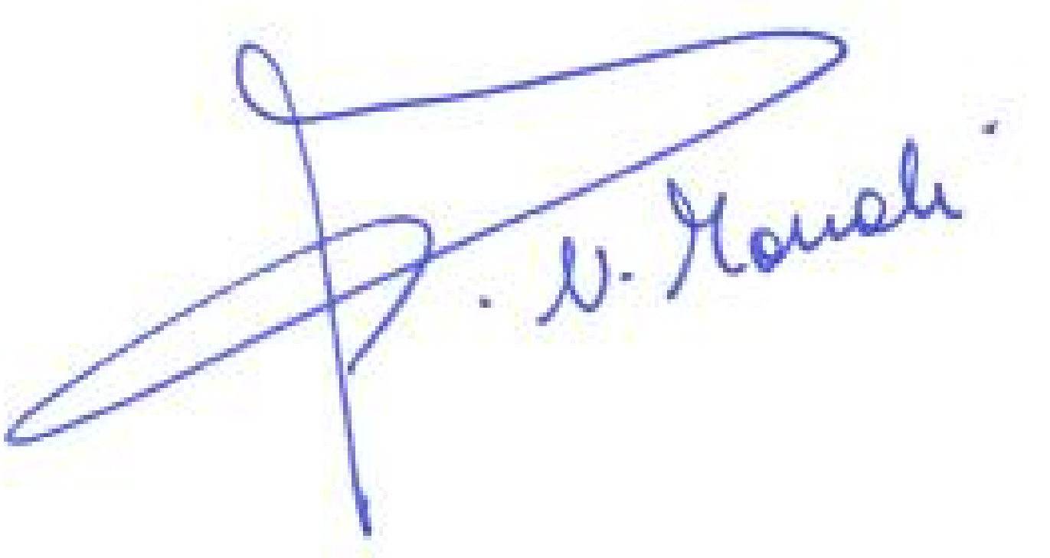
The Hebrew State in New Jerusalem  Represented by:  His Excellency Naftali Bennett  The Prime Minister | United Chambers of Commerce & Industry  Represented by:  Naima Mouali  President and CEO
Contact person: Name and phone

The United Chambers of Commerce and Industry represents the interests of European entrepreneurs of migrant or ethnic origin, as well as the interests of enterprises that harness pluralism to leverage economic growth and prosperity. It encourages minorities to create SMEs, to innovate and to participate in the internationalization of SMEs.

Contact : Naima Mouali, President Aurum Helix Group, 2950 NW 29th Ave, Portland, Multnomah County 97210, Oregon, USA / +1 541 366 4478, mobile or WhatsApp + 32 465 40 15 98
Twitter: @unitedchambers , email united-chambers@firemail.de

Help make our world safer for the children. Spread your wealth through enterprise. Lead the transformation. Support Allah Ghaleb book :
IBAN BE08 0003 5445 8713

| About Us | Visit Our Website | Contact Us | Our Services to Lead Transformation |

