Insert logo here
Memorandum of Understanding (MoU)
Pro Forma
For Public Private Partnerships
This MoU expresses the intention for an association between The Hebrew Ministery of Education in New Jerusalem and the United Chambers of Commerce and Industry (Oregon). The aim of this MoU is to develop new international standards for multicultural community building, which guarantee social inclusion. View our values.

The purpose of the relationship is to facilitate exchanges between our countries, and to build a strategic alliances in common priority fields, which are business and financial research, education, scientific research, entrepreneurship and skills development through programs approved by The Hebrew Ministery of Education in New Jerusalem, as per our letter of Tuesday 29 May, 2018 to the attention of His Excellency Naftali Bennett, the Minister of Education in Jerusalem about transforming the education system to eventually become a 360° or a multi-dimensional education system starts with the DNA-Business-Finance 3D-method, and our letter of Wednesday 13 December 2017 to the attention of His Excellency Prime Minister Benjamin Netanyahu, concerning the Aurum Helix Group portfolio of global projects currently worth 15 trillion 865 billion USD, in the context of restoring multicultural relations in Europe, the GCC, the MENA region and in the world, following the various terrorist attacks in the recent years. Please consult our programs against the violent extremism, and our letter to the investor with the multidimensional portfolio.

For your reference, please find our MoU with the Kingdom of Morocco, which forms the base line.

Starting from June 2018, both organizations will conduct discussions to agree on the programs and the terms for a long term collaboration to deliver advisory services, certification programs, project finance, human resource exchanges and international partnerships.

The present MoU is a pro forma, and subject to modification or termination at any time by the signatories through a letter of exchange.
Amman, insert or paste the date here | Antwerp, 29 May, 2018  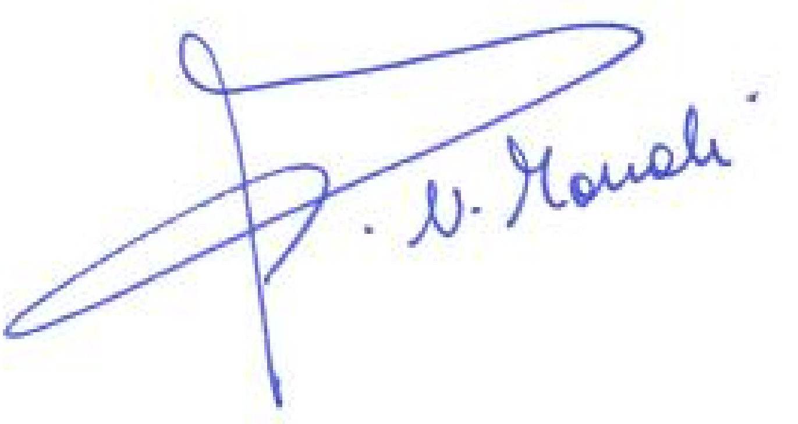
The Hebrew Ministery of Education  Represented by:  His Excellency Naftali Bennett  Minister of Education  Jerusalem | United Chambers of Commerce & Industry  Represented by:  Naima Mouali  President and CEO
Contact person: Name and phone

The United Chambers of Commerce and Industry represents the interests of European entrepreneurs of migrant or ethnic origin, as well as the interests of enterprises that harness pluralism to leverage economic growth and prosperity. It encourages minorities to create SMEs, to innovate and to participate in the internationalization of SMEs.

Contact : Naima Mouali, President Aurum Helix Group, 2950 NW 29th Ave, Portland, Multnomah County 97210, Oregon, USA / +1 541 366 4478, mobile or WhatsApp + 32 465 40 15 98
Twitter: @unitedchambers , email united-chambers@firemail.de

Help make our world safer for the children. Spread your wealth through enterprise. Lead the transformation. Support Allah Ghaleb book :
IBAN BE08 0003 5445 8713

| About Us | Visit Our Website | Contact Us | Our Services to Lead Transformation |

