| About Us | Visit Our Website | Contact Us | Our Services to Lead Transformation | Our History |

Antwerp, Friday 15 September, 2017

Letter for:

His Excellency Benjamin Netanyahu
The President of Israel

Subject:

Aurum Helix Group portfolio worth 15 trillion 865 billion USD (5-10 years maturity)

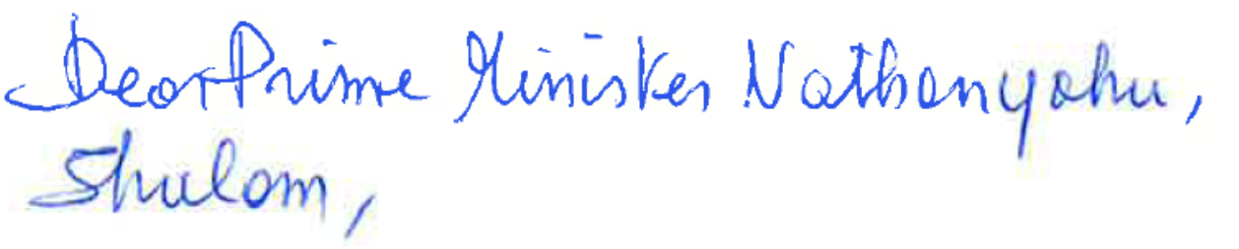

Today, I am visiting the expo “Islam is Also Our History” in Brussels. I dropped everything to go and see it, as soon as I heard about it on the radio, this morning.

If just like me, you are looking to expand the wealth of the people of Israel with new markets, innovations and technology, then I am very pleased to contact you to further the efforts by the Kingdom of Morocco with your country, in a different way.

My name is Naima Mouali and I have the honor to introduce you to the Aurum Helix Group :

The Aurum Helix Group consists of the Multidimensional Innovation Centers, the Anaccell Corporation, the United Chambers of Commerce and Industry, the VAS (Value Added Skills) Training Centers, and the Collaborative Finance Company, among others. The whole Aurum Helix system aims to create sustainable enterprises and fewer bankruptcies.

The Aurum Helix group investment portfolio has recently evolved from 4 trillion 665 billion USD to 15 trillion 865 billion USD of investment which covers businesses that mature between 5 and 10 years.

The three main areas of value which justify the market price of our group are :

- The Diamond Life Incubator which combines a real estate for shopping malls and tourism enterprise incubators for the diamond land in Antwerp, and the strategic corporate finance services around the precious metals and stones. Our incubators are like mini-world trade centers and I have contacted Trump Towers about building one in every country of strong growth.

- Tourism is the vital part of this concept, and our immediate plan is to create partnerships with investors in tourism, hotels, fun parks and entertainment, and with the best travel

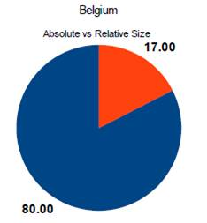
and hospitality academies in the world. Our choice to be in Antwerp will help us benefit from the historic expertise in Belgium to have a tourism sector of which the income and the impact on the GDP is more than four times the total value of the sector itself (see pie on the left). You will find more details about this pie in “Who is Selling the Sun to Whom”.

All the countries would like to learn how to make a tourism pie exactly like this one. Our Diamond Life Incubator in Antwerp will help shape and model the brands for many other countries according to the highest moral and financial standards.

Yet, despite the top ranking tourism figures for Belgium, in terms of income, according to the World Travel and Tourism Council (WTTC), the employment in the Belgian tourism leaves apparently a lot to desire (see page 7 of WTTC report). The diamond traders and jobless ex-workers at the Antwerp diamond industry confirmed to me that there was a sharp decline of tourism in 2012. It didn't pick up much ever since, and another strategy was needed to boost the sector. The Diamond Life Tower is the solution which I suggested to the Mayor of Antwerp. Please have a look in the current program for animating the Diamond Life Tower

Digital Unity, is part of this transformation in the tourism sector and it combines virtual and physical global market creation for the small and medium-sized companies, humanitarian aid and disaster relief services with Speed of Light, high volumes advertisement on a the social card medium, and business globalization support services. I have made the plan known to President Donald Trump when I was very pleased on how the Americans were preparing for Hurricane Harvey.

Why would we do anything if it wasn't for the future generation of citizens around the world. In all our projects, we never forget the children who we want to help rear as responsible multidimensional and multicultural entrepreneurs, who will have an easy contact with anyone in the world and who will travel more than my generation and yours. With the e-interpretation functionality on Digital Unity (Internet II), the language will no longer be a big obstacle as well as with the new e-interpretation capability.

Twitter for Kids which we approach. Things will improve in our world only when we take care of educating well the future men and women to respect one another no matter what color or creed, to respect each other's property, to value each other's talents, and above all to distinguish a friend from an enemy, in the psychology, in the action and in the figures. We will stand out with this application for the children, as there is no social media application specifically made for the children to communicate with the parents and with each other safely, for dialing for help and for learning more about our world. So far, they have only invented parental control.

Yes, I agree that a child has to remain child and learn to socialize with real people rather than through an iPhone or a smartphone. Twitter for Kids works with the same concerns of any parent and it aims to improve the normal contact which the children make with the outside world, which is to talk normally instead of bullying, for instance. It must become something which shapes the thinking, the morals and the behavior in good ways everywhere in the world. It should help them recognize and report unusual situations to the law-enforcement authorities, with just a push on a button. It aims to help the children get used to play or work in partnerships and to boost community building.

Twitter for Kids is an inherent part of Digital Unity ecosystem, the other Internet with which we aim to close the disgraceful digital gap. The application will grow with the child from 6 months to 16 years, which will be referred to as the Twitter generation. It will include games, competitions, “How To's” and a more automated parental control. A child in Malawi, Niger, Haiti or Peru will know as much as a child in New York, Paris, London, Helsinki or Doha. The child of the poor will know as much as the richest children.

This is called “closing the gap”
My letter to Twitter CFO/COO Anthony Noto

- The third high value project is the network of H2O Centers of Excellence for developing new water supply and evacuation system, as well as tourism packages for international business education and water fun.

Please discover more about these three sectors in our letter to the Investors.

Allow me to insist again on a major collaboration project named "From Mawazine to Panama Papers", in which we seek to educate the youth in applying the DNA-Business-Finance methodology for investigating World Wars I and II, and which involves all the universities in the world. It is the step which opens doors to all the other projects that are part of the Aurum Helix portfolio.

While we prudently aim to take it one step at a time, this recent expansion in less than five months tells you who we are. We are definitely not trying to surprise anybody, but the value of our portfolio will increase sharply again with trillions of USD over the next few months with high value sectors such as the other utility infrastructures and the renewable energy, the airport incubator development, the excellence centers in shipbuilding, the aircraft building, the trains, and the e-commerce for DNA-Driven health care which will be featured in our next letter to the Investor.

Aurum Helix develops exciting projects which combine plans for improving simultaneously the social, the economic and the environmental aspects, and for the growth of your company in this way. Growth is inevitable when one thinks and operates in a multidimensional and in a multicultural way. There is no more reason for new ideas to stop coming which leads to busts. There will be no more financial crises, recessions, and bankruptcies like in the previous economy.

That is our promise. Please read our letter to the investor for further details, and let me know who in Israel or else might be interested in participating in our investment programs.

Should there be any interest for a partnership, then please find enclosed a provisional pro-forma MoU.

With deep gratitude in advance, may I request your help in making our projects real and in keeping the promise, every day. Your investment or donation, today, however small, will immediately make a big difference tomorrow for many children, especially in Africa.

Should you have questions or if you need more details, please do not hesitate to contact me, Your Excellency Benjamin Netanyahu. My details are further below. I will be really very happy to answer all your questions.

Beforehand I thank you greatly for your support.
Yours sincerely,
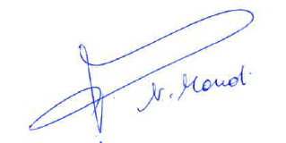

Naima Mouali
President of United Chambers and Innovation Consultant
Founder of Anaccell Corporation
e-mail : unitedchambers@firemail.de
Phone:+ 1 541 366 4478
WhatsApp + 32 465 40 15 98
Fax : + 44 (0) 871 314 0556
Twitter: @unitedchambers @meedanaltatweer

Attachment : Letter to the Investor

Help make our world safer for the children. Spread your wealth through enterprise. Lead the transformation. Support Allah Ghaleb book :
IBAN BE08 0003 5445 8713

